**LAB CYCLE 4**

1. **Using the iris data set implement the KNN algorithm. Take different values for Test and training data set. Also use different values for k. Also find the accuracy level.**

**CODE**

import numpy as np

import matplotlib.pyplot as plt

import pandas as pd

dataset = pd.read_csv("iris.csv")

X = dataset.iloc[:, :-1].values

y = dataset.iloc[:, 4].values

from sklearn.model_selection import train_test_split

X_train, X_test, y_train, y_test = train_test_split(X, y, test_size=0.20)

from sklearn.neighbors import KNeighborsClassifier

classifier = KNeighborsClassifier(n_neighbors=5)

classifier.fit(X_train, y_train)

y_pred = classifier.predict(X_test)

from sklearn.metrics import classification_report, confusion_matrix

print(classification_report(y_test, y_pred))

from sklearn.metrics import accuracy_score

print ("Accuracy : ", accuracy_score(y_test, y_pred))

df = pd.DataFrame({'Real Values':y_test, 'Predicted Values':y_pred})

df

**OUTPUT**

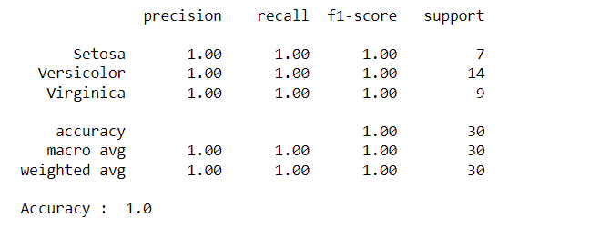

Reference: <https://stackabuse.com/k-nearest-neighbors-algorithm-in-python-and-scikit-learn/>

1. **Download another data set suitable for the KNN and implement the KNN algorithm. Take different values for Test and training data set. Also use different values for k.**

**CODE**

import numpy as np

import matplotlib.pyplot as plt

import pandas as pd

dataset = pd.read_csv("cancer.csv")

dataset.head()

dataset.info()

X = dataset.iloc[:, 2:35].values

print(X)

y = dataset.iloc[:, 1].values

print(y)

from sklearn.model_selection import train_test_split

X_train, X_test, y_train, y_test = train_test_split(X, y, test_size=0.20)

from sklearn.neighbors import KNeighborsClassifier

classifier = KNeighborsClassifier(n_neighbors=5)

classifier.fit(X_train, y_train)

y_pred = classifier.predict(X_test)

from sklearn.metrics import classification_report, confusion_matrix

print(classification_report(y_test, y_pred))

from sklearn.metrics import accuracy_score

print ("Accuracy : ", accuracy_score(y_test, y_pred))

df = pd.DataFrame({'Real Values':y_test, 'Predicted Values':y_pred})

df

**OUTPUT**

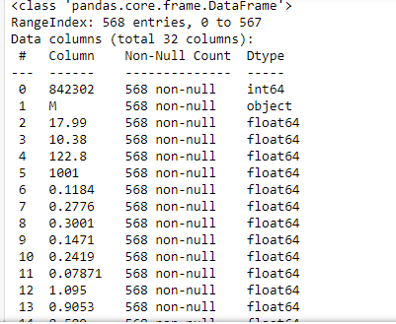

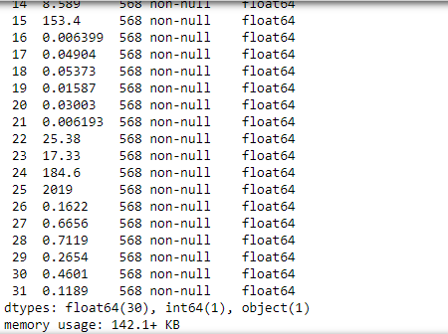

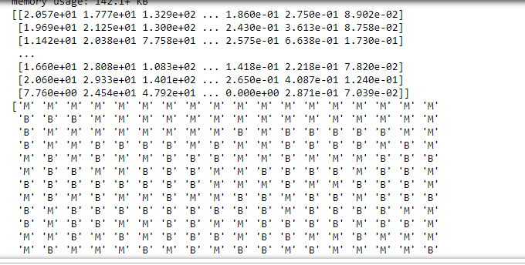

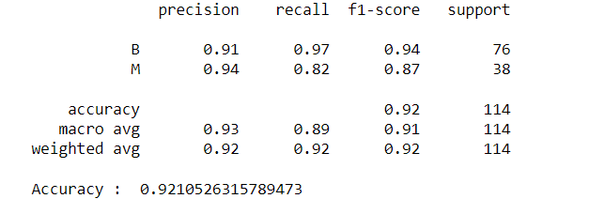

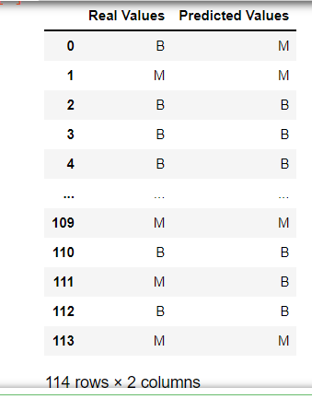

1. **Using iris data set, implement naive bayes classification for different naive Bayes classification algorithms. ((i) gaussian (ii) bernoulli etc)**

* **Find out the accuracy level w.r.t to each algorithm**
* **Display the no:of mislabeled classification from test data set**
* **List out the class labels of the mismatching records**

**i)CODE**

import numpy as np

import matplotlib.pyplot as plt

import pandas as pd

dataset = pd.read_csv('iris.csv')

X = dataset.iloc[:,:4].values

y = dataset['variety'].values

dataset.head(5)

from sklearn.model_selection import train_test_split

X_train, X_test, y_train, y_test = train_test_split(X, y, test_size = 0.2)

from sklearn.naive_bayes import GaussianNB

classifier = GaussianNB()

classifier.fit(X_train, y_train)

y_pred = classifier.predict(X_test)

y_pred

from sklearn.metrics import confusion_matrix

cm = confusion_matrix(y_test, y_pred)

from sklearn.metrics import accuracy_score

print ("Accuracy : ", accuracy_score(y_test, y_pred))

cm

df = pd.DataFrame({'Real Values':y_test, 'Predicted Values':y_pred})

df

**OUTPUT**

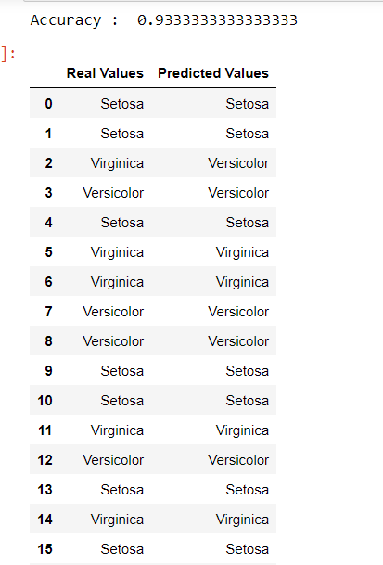

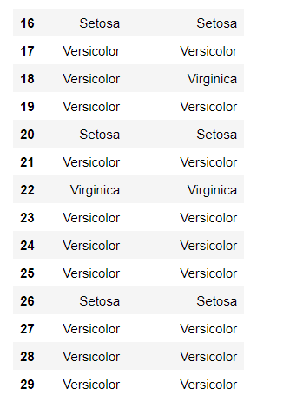

**CODE**

import numpy as np

import matplotlib.pyplot as plt

import pandas as pd

dataset = pd.read_csv('iris.csv')

X = dataset.iloc[:,:4].values

y = dataset['variety'].values

dataset.head(5)

from sklearn.model_selection import train_test_split

X_train, X_test, y_train, y_test = train_test_split(X, y, test_size = 0.2)

from sklearn.naive_bayes import BernoulliNB

classifier = BernoulliNB()

classifier.fit(X_train, y_train)

y_pred = classifier.predict(X_test)

y_pred

from sklearn.metrics import confusion_matrix

cm = confusion_matrix(y_test, y_pred)

from sklearn.metrics import accuracy_score

print ("Accuracy : ", accuracy_score(y_test, y_pred))

cm

# df = pd.DataFrame({'Real Values':y_test, 'Predicted Values':y_pred})

# df

**OUTPUT**

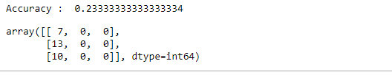

**ii)CODE**

import numpy as np

import matplotlib.pyplot as plt

import pandas as pd

dataset = pd.read_csv('iris.csv')

X = dataset.iloc[:,:4].values

y = dataset['variety'].values

dataset.head(5)

from sklearn.model_selection import train_test_split

X_train, X_test, y_train, y_test = train_test_split(X, y, test_size = 0.2)

from sklearn.naive_bayes import BernoulliNB

classifier = BernoulliNB()

classifier.fit(X_train, y_train)

y_pred = classifier.predict(X_test)

y_pred

#from sklearn.metrics import confusion_matrix

#cm = confusion_matrix(y_test, y_pred)

from sklearn.metrics import accuracy_score

print ("Accuracy : ", accuracy_score(y_test, y_pred))

#cm

df = pd.DataFrame({'Real Values':y_test, 'Predicted Values':y_pred})

df

**OUTPUT**

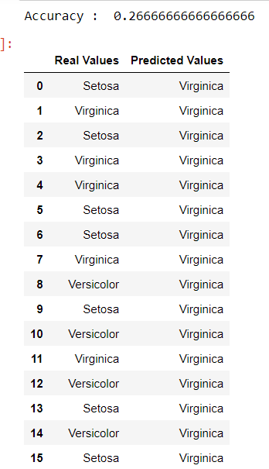

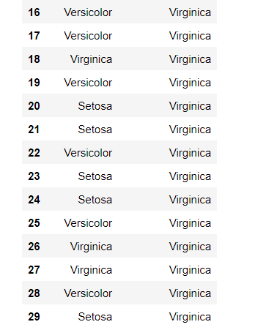

References:

<https://towardsdatascience.com/machine-learning-basics-naive-bayes-classification-964af6f2a965>

<https://scikit-learn.org/stable/modules/classes.html#module-sklearn.naive_bayes>

1. **Use car details CSV file and implement decision tree algorithm**

* **Find out the accuracy level.**
* **Display the no: of mislabelled classification from test data set**
* **List out the class labels of the mismatching records**

import os

import numpy as np

import pandas as pd

import numpy as np, pandas as pd

import matplotlib.pyplot as plt

from sklearn import tree, metrics, model_selection

data = pd.read_csv('car.csv',names=['buying','maint','doors','persons','lug_boot','safety','class'])

data.head()

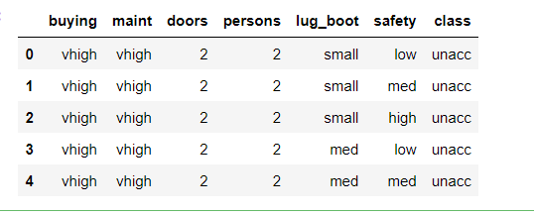

data.info()

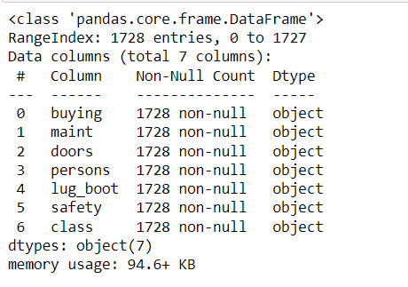

data['class'],class_names = pd.factorize(data['class'])

print(class_names)

print(data['class'].unique())

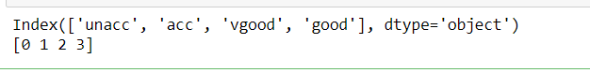

data['buying'],_ = pd.factorize(data['buying'])

data['maint'],_ = pd.factorize(data['maint'])

data['doors'],_ = pd.factorize(data['doors'])

data['persons'],_ = pd.factorize(data['persons'])

data['lug_boot'],_ = pd.factorize(data['lug_boot'])

data['safety'],_ = pd.factorize(data['safety'])

data.head()

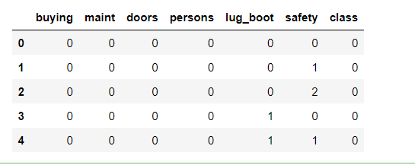

data.info()

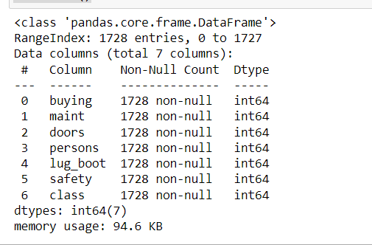

X = data.iloc[:,:-1]

y = data.iloc[:,-1]

# split data randomly into 70% training and 30% test

X_train, X_test, y_train, y_test = model_selection.train_test_split(X, y, test_size=0.3, random_state=0)

# train the decision tree

dtree = tree.DecisionTreeClassifier(criterion='entropy', max_depth=3, random_state=0)

dtree.fit(X_train, y_train)



# use the model to make predictions with the test data

y_pred = dtree.predict(X_test)

# how did our model perform?

accuracy = metrics.accuracy_score(y_test, y_pred)

print('Accuracy: {:.2f}'.format(accuracy))



count_misclassified = (y_test != y_pred).sum()

print('Misclassified samples: {}'.format(count_misclassified))



References:

<https://www.24tutorials.com/machine-learning/case-study-decision-tree-model-for-car-quality/>

<https://notebook.community/bMzi/ML_in_Finance/0210_DecisionTrees>

<https://stackabuse.com/decision-trees-in-python-with-scikit-learn/>

For Data Sets Refer:

<https://www.kaggle.com> ( for data set)

<http://archive.ics.uci.edu/ml/datasets.php>

**REGRESSION**

1. **Implement Simple and multiple linear regression for the data sets ‘student_score.csv’ and ‘company_data .csv’ respectively**

Ref:  <https://stackabuse.com/linear-regression-in-python-with-scikit-learn/>

**Simple Linear Regression**

import numpy as np

import pandas as pd

import matplotlib.pyplot as plt

#data set contains details of no.of hours spend by students for studt and their marks

student = pd.read_csv('student_scores.csv')

student.head()

student.describe()

**OUTPUT:**

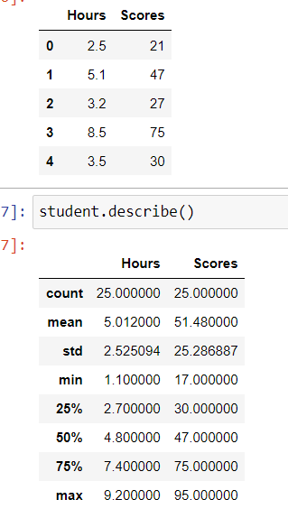

student.info()

**OUTPUT:**

<class 'pandas.core.frame.DataFrame'>

RangeIndex: 25 entries, 0 to 24

Data columns (total 2 columns):

# Column Non-Null Count Dtype

--- ------ -------------- -----

0 Hours 25 non-null float64

1 Scores 25 non-null int64

dtypes: float64(1), int64(1)

memory usage: 528.0 bytes

import matplotlib.pyplot as plt

Xax=student.iloc[:,0]

Yax=student.iloc[:,1]

plt.scatter(Xax,Yax)

plt.xlabel("No.of hours")

plt.ylabel("Score")

plt.title("Student scores")

plt.show()

**OUTPUT:**

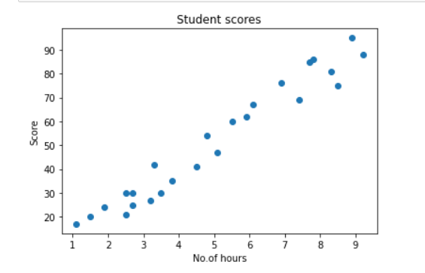

#Perform the simple linear regression model

#Equation: Y=w0+w1.x

#Here Y(marks)=w0+w1.x

#Create x as hours and Y as marks

X = student.iloc[:, :-1]

y = student.iloc[:, 1]

print(X)

**OUTPUT:**

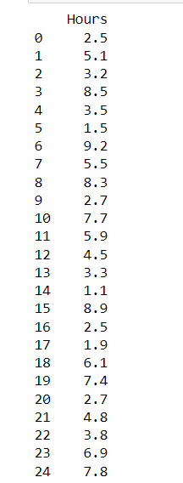

print(y)

**OUTPUT:**

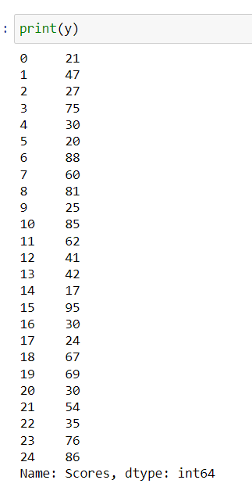

from sklearn.model_selection import train_test_split

X_train, X_test, y_train, y_test = train_test_split(X, y, test_size=0.2)

print(X_train)

**OUTPUT:**

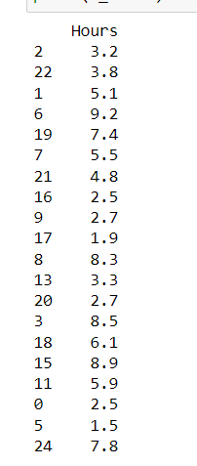

from sklearn.linear_model import LinearRegression

regressor = LinearRegression()

regressor.fit(X_train, y_train)

**OUTPUT:**

LinearRegression()

print(regressor.intercept_)

**OUTPUT:**

3.4157789720979608

print(regressor.coef_)

**OUTPUT:**

[9.544138]

y_pred = regressor.predict(X_test)

for(i,j) in zip(y_test,y_pred):

if i!=j:

print("Actual value :",i,"Predicted value :",j)

print("Number of mislabeled points from test data set :", (y_test != y_pred).sum())

**OUTPUT:**

Actual value : 76 Predicted value : 69.2703311556657

Actual value : 41 Predicted value : 46.36439996138126

Actual value : 85 Predicted value : 76.90564155376049

Actual value : 17 Predicted value : 13.914330769478324

Actual value : 30 Predicted value : 36.82026196376275

Number of mislabeled points from test data set : 5

from sklearn import metrics

print("Mean Absolute error :", metrics.mean_absolute_error(y_test,y_pred))

print("Mean Squared error :", metrics.mean_squared_error(y_test,y_pred))

print("Root Mean Squared error :", np.sqrt(metrics.mean_squared_error(y_test,y_pred)))

**OUTPUT:**

Mean Absolute error : 6.0188716892478995

Mean Squared error : 39.124239242163426

Root Mean Squared error : 6.254937189306014

import matplotlib.pyplot as plt

c=X_test['Hours'].count()

xax=np.arange(c)

print(xax)

X_axis = np.arange(len(xax))

plt.bar(X_axis-0.2, y_test, 0.6, label='Actual')

plt.bar(X_axis+0.2, y_pred, 0.6, label='Predicted')

plt.xlabel("Test Records")

plt.ylabel("Marks")

plt.title("Student Score prediction")

plt.legend()

plt.show()

**OUTPUT:**

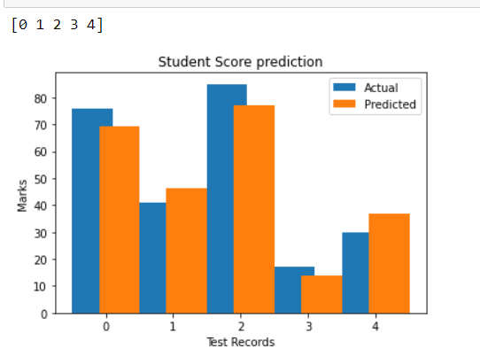

1. **Multiple Linear Regression**

import pandas as pd

import numpy as np

import matplotlib.pyplot as plt

advertising = pd.read_csv('Company_data.csv')

advertising.head()

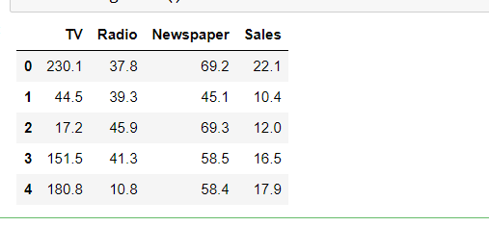

advertising.describe()

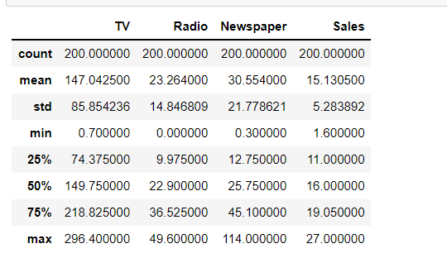

advertising.info()

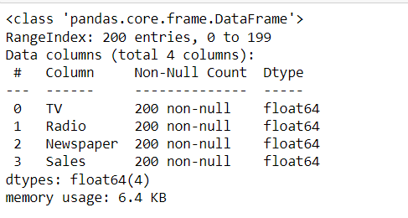

import matplotlib.pyplot as plt

import seaborn as sns

sns.pairplot(advertising, x_vars=['TV', 'Radio', 'Newspaper'],

y_vars='Sales', height=5, aspect=1, kind='scatter')

plt.show()

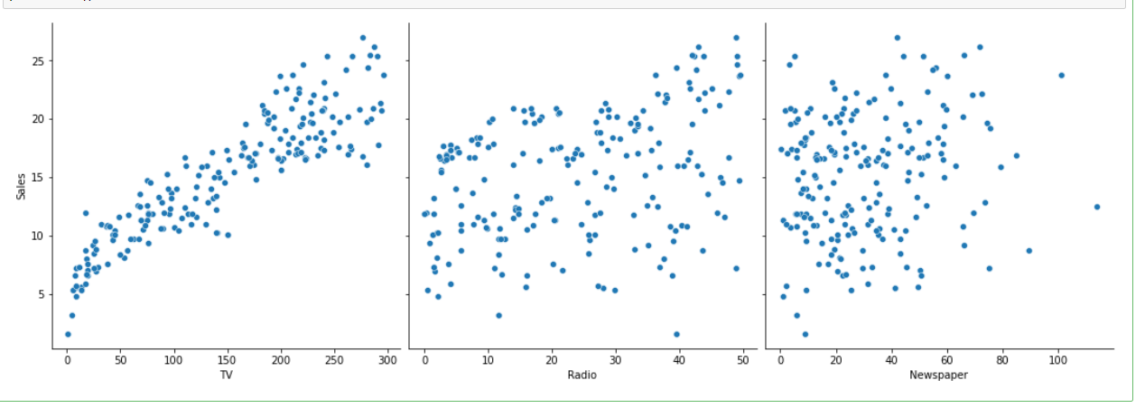

#perform the multiple linear regression model

#Equation : Y=w0+w1.x1 + w2.x2 + w3.x3

#Here Y(sales)=w0+w1.x1(TV)+w2.x2(Radio)+w3.x3(Newspaper)

#create x and Y as sales

X = advertising.iloc[:, :-1]

print(X)

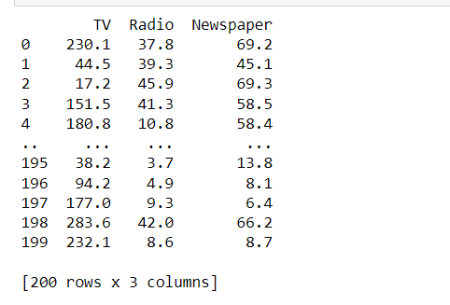

y = advertising.iloc[:, -1]

print(y)

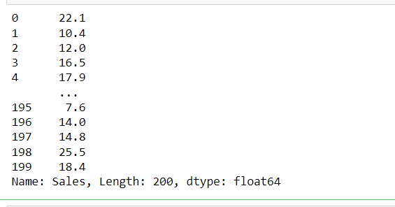

from sklearn.model_selection import train_test_split

X_train, X_test, y_train, y_test = train_test_split(X, y, test_size=0.3)

print(X_train)

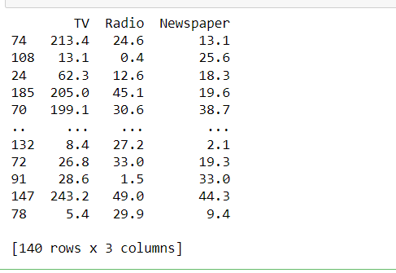

from sklearn.linear_model import LinearRegression

regressor = LinearRegression()

regressor.fit(X_train, y_train)



print(regressor.intercept_)

o/p: 4.834885358384083

print(regressor.coef_)

o/p :[ 0.05441868 0.11045214 -0.00292727]

y_pred = regressor.predict(X_test)

for(i,j) in zip(y_test,y_pred):

if i!=j:

print("Actual value :",i,"Predicted value :",j)

print("Number of mislabeled points from test data set :", (y_test != y_pred).sum())

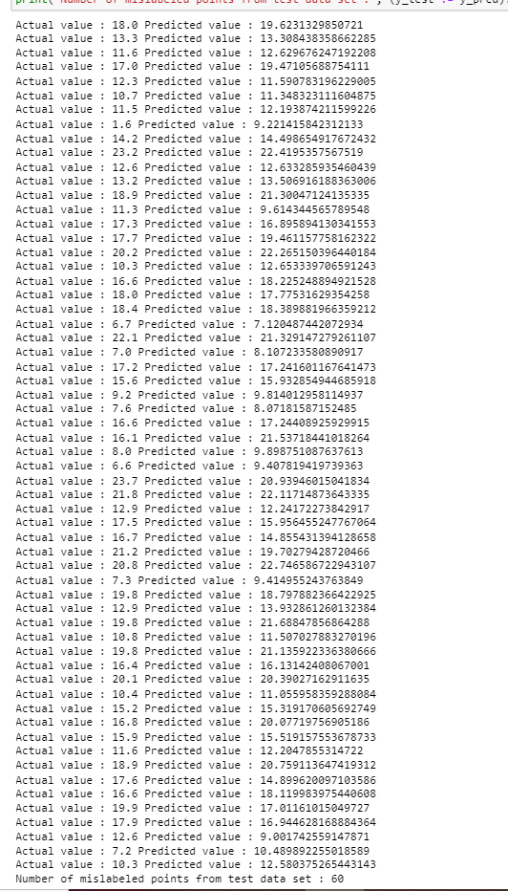

from sklearn import metrics

print("Mean Absolute error :", metrics.mean_absolute_error(y_test,y_pred))

print("Mean Squared error :", metrics.mean_squared_error(y_test,y_pred))

print("Root Mean Squared error :", np.sqrt(metrics.mean_squared_error(y_test,y_pred)))

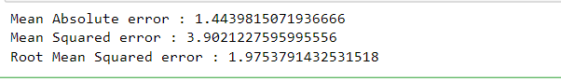

import matplotlib.pyplot as plt

c=X_test['TV'].count()

xax=np.arange(c)

print(xax)

X_axis = np.arange(len(xax))

plt.bar(X_axis-0.2, y_test, 0.6, label='Actual')

plt.bar(X_axis+0.2, y_pred, 0.6, label='Predicted')

plt.xlabel("Sales")

plt.ylabel("Actual/Predicted")

plt.title("Sales prediction")

plt.legend()

plt.show()

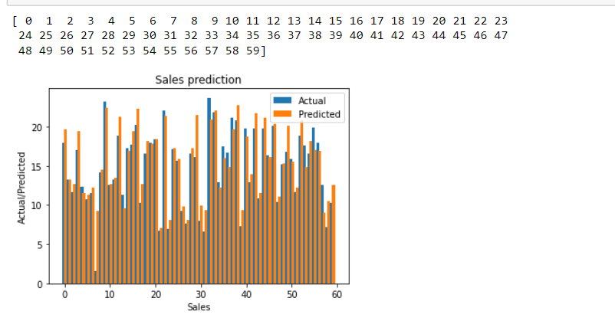

**NEURAL NETWORK**

1. **Create a neural network for the given ‘houseprice.csv’ to predict the whether price of the house is above or below median value or not.**

import tensorflow as tf

import keras

import pandas

import sklearn

import matplotlib

import pandas as pd

df=pd.read_csv('housepricedata.csv')

df

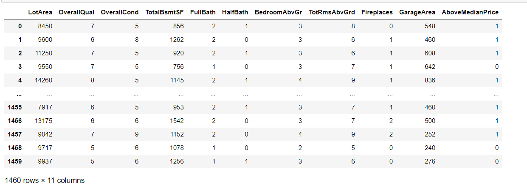

dataset = df.values

X = dataset[:,0:10]

Y = dataset[:,10]

from sklearn import preprocessing

min_max_scaler = preprocessing.MinMaxScaler()

X_scale = min_max_scaler.fit_transform(X)

X_scale

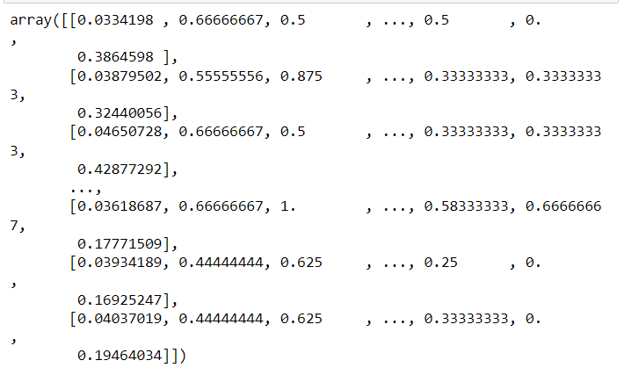

from sklearn.model_selection import train_test_split

X_train, X_val_and_test, Y_train, Y_val_and_test = train_test_split(X_scale, Y, test_size=0.3)

X_val, X_test, Y_val, Y_test = train_test_split(X_val_and_test, Y_val_and_test, test_size=0.5)

print(X_train.shape, X_val.shape, X_test.shape, Y_train.shape, Y_val.shape, Y_test.shape)



from keras.models import Sequential

from keras.layers import Dense

model = Sequential([

Dense(32, activation='relu', input_shape=(10,)),

Dense(32, activation='relu'),

Dense(1, activation='sigmoid'),

])

model.compile(optimizer='sgd',

loss='binary_crossentropy',

metrics=['accuracy'])

hist = model.fit(X_train, Y_train,

batch_size=32, epochs=100,

validation_data=(X_val, Y_val))

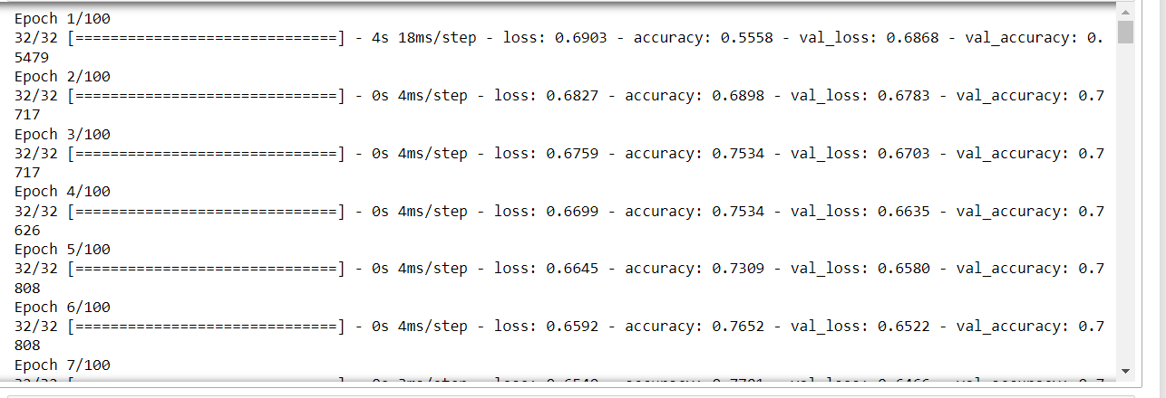

model.evaluate(X_test, Y_test)[1]

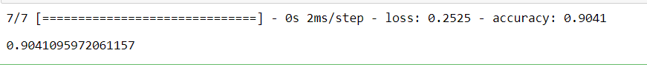

import matplotlib.pyplot as plt

plt.plot(hist.history['loss'])

plt.plot(hist.history['val_loss'])

plt.title('Model loss')

plt.ylabel('Loss')

plt.xlabel('Epoch')

plt.legend(['Train', 'Val'], loc='upper right')

plt.show()

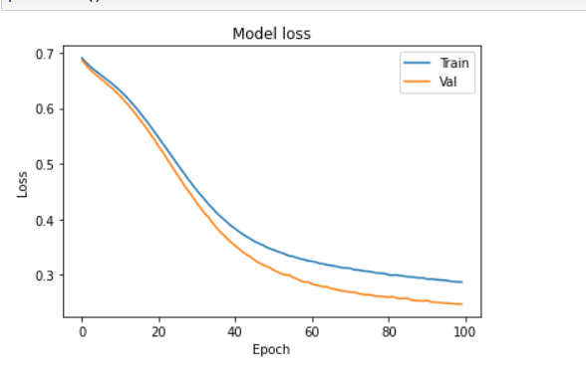

plt.plot(hist.history['accuracy'])

plt.plot(hist.history['val_accuracy'])

plt.title('Model accuracy')

plt.ylabel('Accuracy')

plt.xlabel('Epoch')

plt.legend(['Train', 'Val'], loc='lower right')

plt.show()

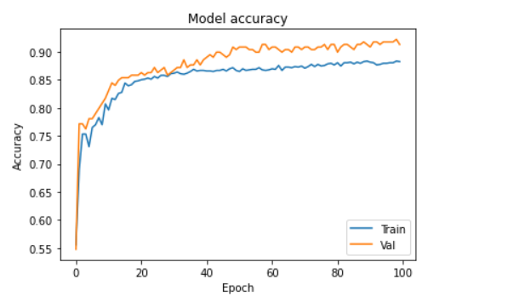

model_2 = Sequential([

Dense(1000, activation='relu', input_shape=(10,)),

Dense(1000, activation='relu'),

Dense(1000, activation='relu'),

Dense(1000, activation='relu'),

Dense(1, activation='sigmoid'),

])

model_2.compile(optimizer='adam',

loss='binary_crossentropy',

metrics=['accuracy'])

hist_2 = model_2.fit(X_train, Y_train,

batch_size=32, epochs=100,

validation_data=(X_val, Y_val))

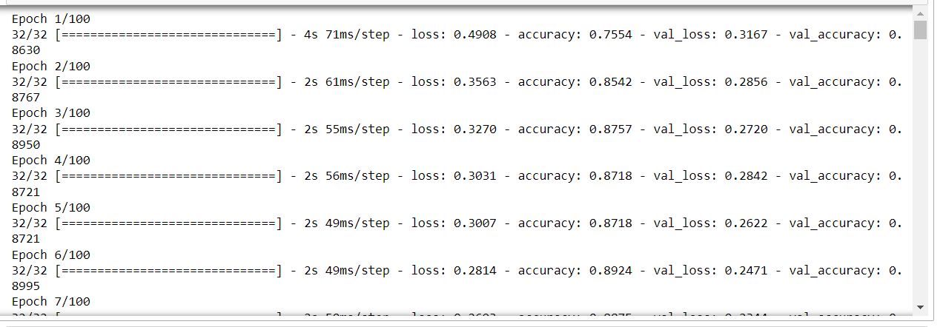

plt.plot(hist_2.history['loss'])

plt.plot(hist_2.history['val_loss'])

plt.title('Model loss')

plt.ylabel('Loss')

plt.xlabel('Epoch')

plt.legend(['Train', 'Val'], loc='upper right')

plt.show()

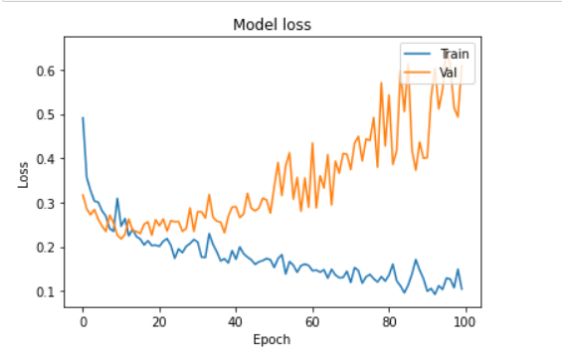

plt.plot(hist_2.history['accuracy'])

plt.plot(hist_2.history['val_accuracy'])

plt.title('Model accuracy')

plt.ylabel('Accuracy')

plt.xlabel('Epoch')

plt.legend(['Train', 'Val'], loc='lower right')

plt.show()

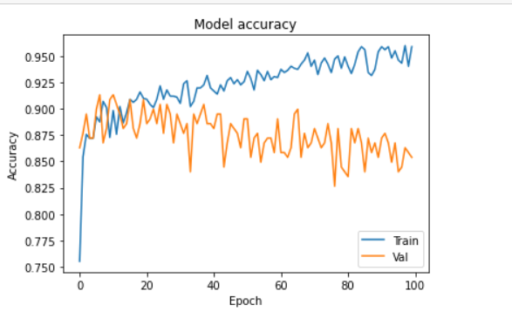

from keras.layers import Dropout

from keras import regularizers

model_3 = Sequential([

Dense(1000, activation='relu', kernel_regularizer=regularizers.l2(0.01), input_shape=(10,)),

Dropout(0.3),

Dense(1000, activation='relu', kernel_regularizer=regularizers.l2(0.01)),

Dropout(0.3),

Dense(1000, activation='relu', kernel_regularizer=regularizers.l2(0.01)),

Dropout(0.3),

Dense(1000, activation='relu', kernel_regularizer=regularizers.l2(0.01)),

Dropout(0.3),

Dense(1, activation='sigmoid', kernel_regularizer=regularizers.l2(0.01)),

])

model_3.compile(optimizer='adam',

loss='binary_crossentropy',

metrics=['accuracy'])

hist_3 = model_3.fit(X_train, Y_train,

batch_size=32, epochs=100,

validation_data=(X_val, Y_val))

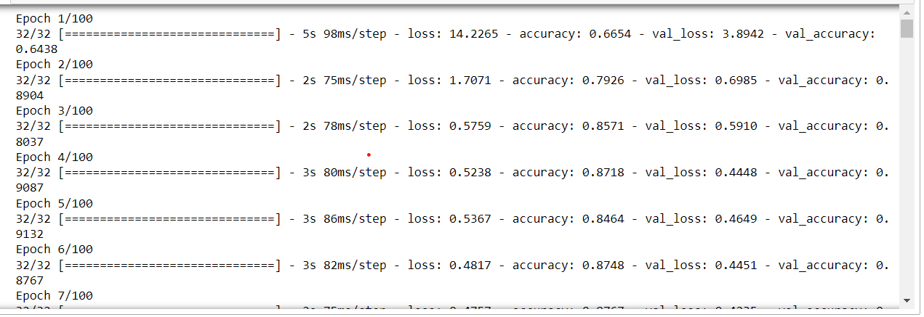

plt.plot(hist_3.history['loss'])

plt.plot(hist_3.history['val_loss'])

plt.title('Model loss')

plt.ylabel('Loss')

plt.xlabel('Epoch')

plt.legend(['Train', 'Val'], loc='upper right')

plt.ylim(top=1.2, bottom=0)

plt.show()

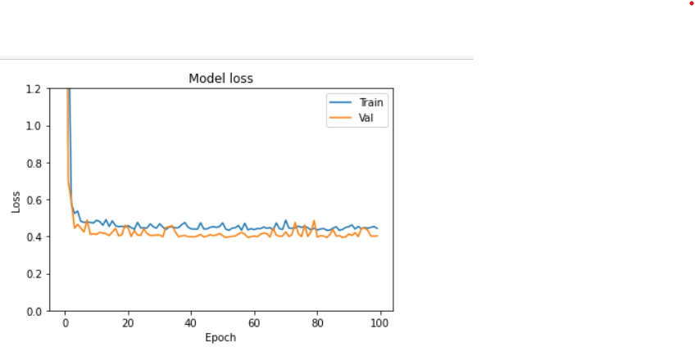

plt.plot(hist_3.history['accuracy'])

plt.plot(hist_3.history['val_accuracy'])

plt.title('Model accuracy')

plt.ylabel('Accuracy')

plt.xlabel('Epoch')

plt.legend(['Train', 'Val'], loc='lower right')

plt.show()

